**ТАШКЕНТСКИЙ МЕЖДУНАРОДНЫЙ УНИВЕРСИТЕТ ОБРАЗОВАНИЯ**



**КУРСОВАЯ РАБОТА**

**по дисциплине**

**«Разработка программного продукта»**

|  |
| --- |
| ВЫПОЛНИЛ: |
| Машарипов Зафарбек Жуманазар угли |
| Студент 1 курса группы RI1-03  Направления информационные технологии |

Ташкент 2022 г.

**ОГЛАВЛЕНИЕ**

1.Постановка Задачи приложения 3

**Проблема 3**

**Требования 4**

3.Функциональная структура 6

4.Agile 6

5.UML-Диаграмма 7

6.QR-CODE 8

# **1.Постановка Задачи приложения**

### **Проблема**

**Проекты по модернизации аэропортов**

На сегодняшний день имеется ряд вопросов, требующих решения в ближайшем будущем, связанных с инфраструктурой аэропортов, состоянием их взлетно-посадочных полос и пассажирских терминалов, стандартов обслуживания в аэропортах. Ожидается, что указанные меры повысят привлекательность авиационного сектора нашей страны для иностранных авиаперевозчиков.

Запланировано осуществление ряда крупных проектов по улучшению состояния аэропортов. В частности, предусмотрено строительство нового пассажирского терминала и взлетно-посадочной полосы Международного аэропорта "Самарканд", что позволит увеличить пропускную способность аэропорта с 500 пассажиров до 1500 пассажиров в час.

В результате оптимизации и реконструкции Международного аэропорта "Ташкент" с участием немецких специалистов пропускная способность аэропорта будет увеличена с 4 до 7 миллионов пассажиров в год.

### **Требования**

При проектировании необходимо учитывать следующие функциональные требования (FR).

И нефункциональные требования (NFT):

1.FT: Пользователь должен совершать платежи онлайн.

2.FT: Пользователь может получить максимальную отдачу от приложения.

3. FT: Пользователь может видеть автоматический статус в приложении.

4.FT: Все поставщики должны доставлять свои заказы пользователям вовремя

5.FT: Пользователь должен правильно указать адрес для приложения

6. FT: Внутренняя система: клиент предоставляет внутреннюю систему с несколькими службами для использования в программе.

7. FT: пользователь может оставлять комментарии или читать комментарии пользователей.

1. NFT: Доступность. Приложение должно быть интуитивно понятным, а пользовательский интерфейс должен быть понятным. Все взаимодействия должны заканчиваться тремя кликами.

2. NFT: целевая платформа: приложение должно быть разработано на Python.

3. Дополнительные ограничения:

• Система управления версиями должна быть Git.

• Документы с исходным кодом должны быть в формате HTML.

**3.Функциональная структура**

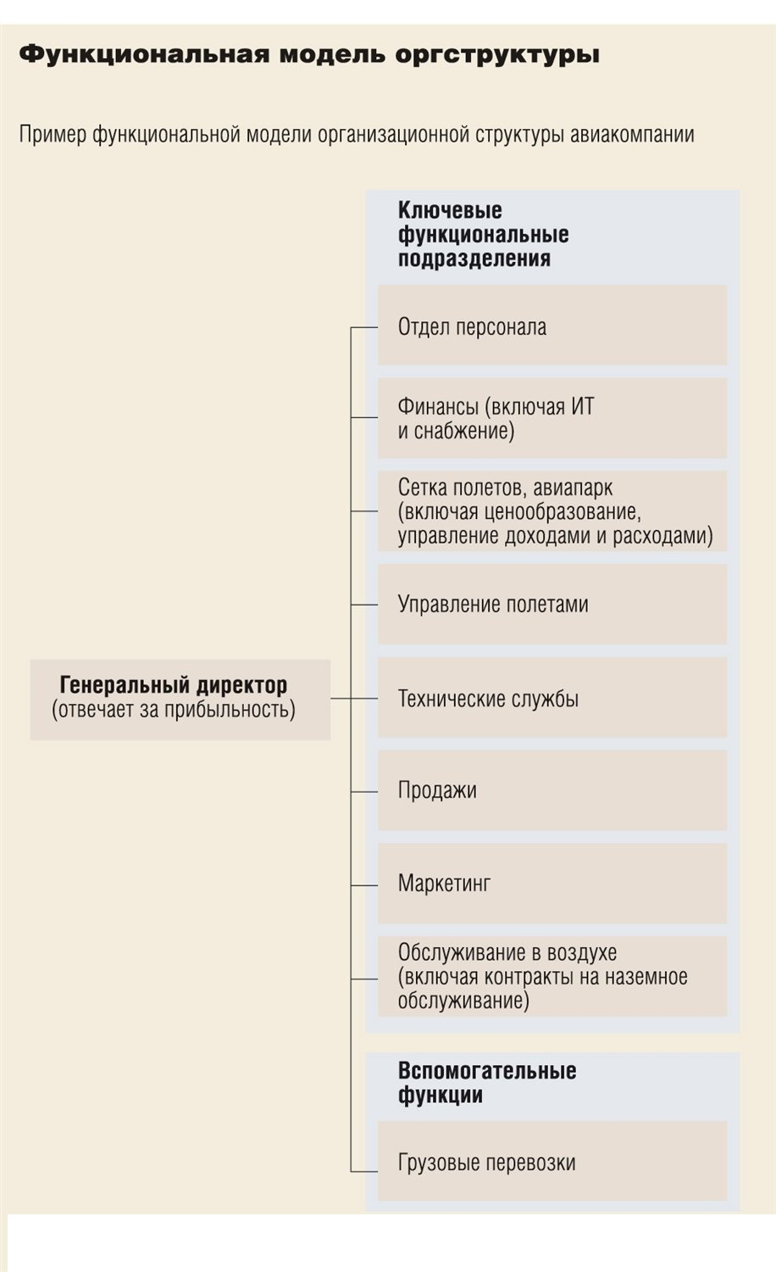

# 

# **4.Agile**

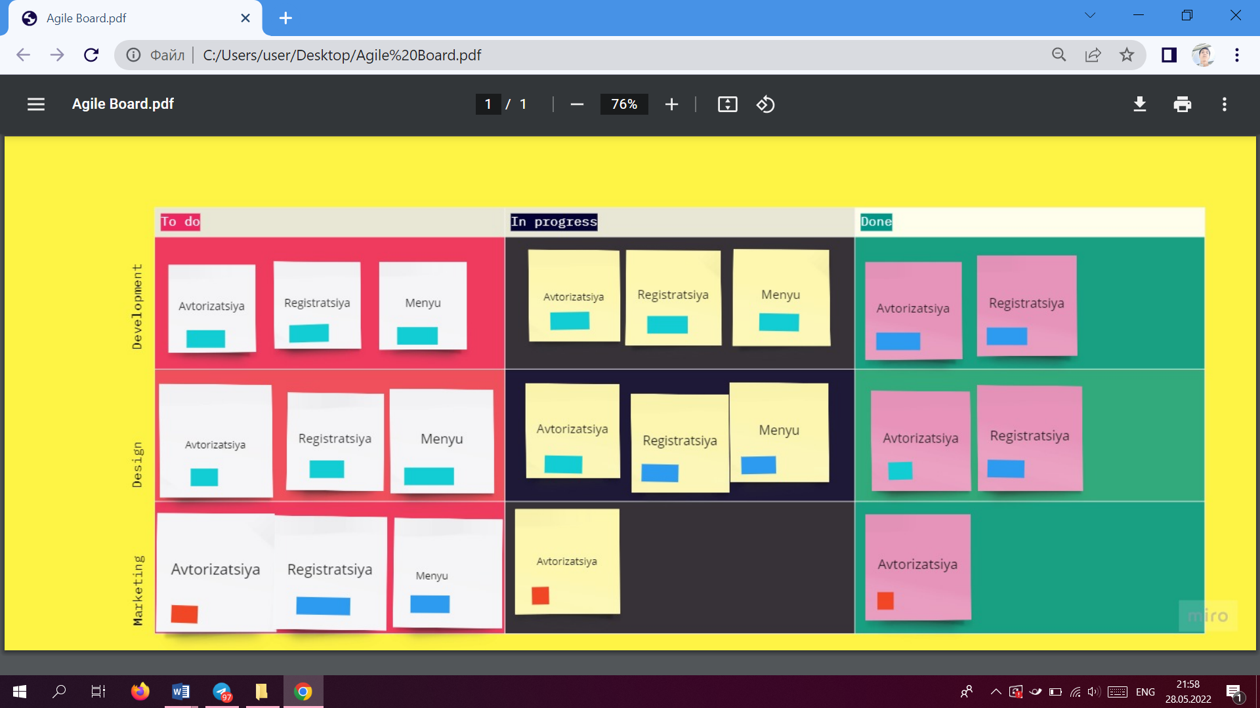

# **5.UML-Диаграмма**

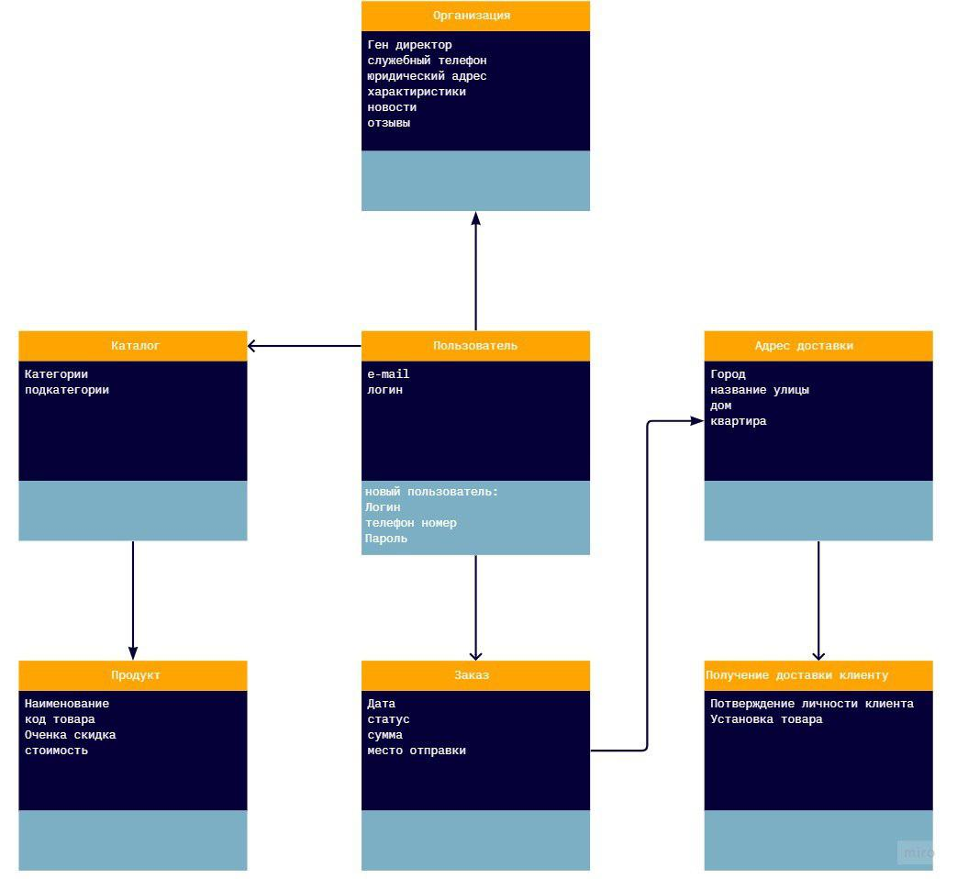

# **6.Исходный код программы**

from tkinter import *

from tkinter.messagebox import *

import sqlite3

root=Tk()

root.title("intro")

con=sqlite3.Connection('flight_db')

cur=con.cursor()

cur.execute("create table if not exists airlines(user_name varchar(20) primary key,first_name varchar(20),last_name varchar(20),phone_number number(10),email varchar(30),passw varchar(20))")

fr2=Frame()

fr2.pack(side=LEFT,expand=1)

Label(fr2,text="Project Submitted By",font=("algerian",38),compound="center",fg="blue").pack()

Label(fr2,text="Zafar Masharipov",font=("Bauhaus 93",14),fg="blue",compound="center").pack()

def airline():

root.destroy()

root1=Tk()

root1.title("Booking Portal")

b=PhotoImage(file='My project.png')

Label(root1,image=b).grid(row=0,column=0,columnspan=4)

Label(root1,text="Welcome to TIUE Airline Booking System",font=("Bauhaus 93",17),fg="white",width=46,bg="blue").grid(row=0,column=0,columnspan=4)

Label(root1,text="Flights Availability",font=("Bauhaus 93",17),fg="White",width=46,bg="blue").grid(row=1,column=0,columnspan=4)

Label(root1,text="Select Pick Up Point",font=("Bauhaus 93",14),fg="Blue").grid(row=2,column=1)

variable = StringVar(root1)

variable.set("Select Source") # default value

w = OptionMenu(root1, variable, "Delhi", "Kolkata", "Mumbai","U.S.A","Canada")

w.grid(row=2,column=2)

Label(root1,text="Select Boarding Point",font=("Bauhaus 93",14),fg="Blue").grid(row=3,column=1)

variable1 = StringVar(root1)

variable1.set("Select Destination") # default value

w = OptionMenu(root1, variable1, "Delhi", "Kolkata", "Mumbai","U.S.A","Canada")

w.grid(row=3,column=2)

#Sign In

def signup():

def success():

user = user_name.get()

cur.execute("select user_name from airlines where user_name=(?)", (user,))

a = cur.fetchall()

if a != []:

showerror('Error',"Username Already Exists")

else:

l = (user_name.get(), first_name.get(), last_name.get(),phone_number.get(),email.get(), passw.get())

cur.execute("insert into airlines values(?,?,?,?,?,?)",l)

showinfo('Signed Up',"Congratulation You are Successfully Signed Up")

con.commit()

user_name.delete(0,20)

first_name.delete(0,20)

last_name.delete(0,20)

phone_number.delete(0,10)

email.delete(0,30)

passw.delete(0,20)

root1.destroy()

root=Tk()

root.title("Sign Up")

d=PhotoImage(file="tiue.png")

Label(root,image=d).grid(row=0,column=0,columnspan=4)

Label(root,text="Welcome to Airline Booking Systems",font=("Bauhaus 93",17),fg="Red",width=46,bg="White").grid(row=0,column=0,columnspan=4)

Label(root,text="Sign Up",font=("Bauhaus 93",17),fg="White",width=46,bg="red").grid(row=1,column=0,columnspan=4)

Label(root,text="Username",font=("Bauhaus 93",14),fg="blue").grid(row=2,column=1)

user_name=Entry()

user_name.grid(row=2,column=2)

Label(root,text="First Name",font=("Bauhaus 93",14),fg="blue").grid(row=3,column=1)

first_name=Entry()

first_name.grid(row=3,column=2)

Label(root,text="Last Name",font=("Bauhaus 93",14),fg="blue").grid(row=4,column=1)

last_name=Entry()

last_name.grid(row=4,column=2)

Label(root,text="Phone Number",font=("Bauhaus 93",14),fg="blue").grid(row=5,column=1)

phone_number=Entry()

phone_number.grid(row=5,column=2)

Label(root,text="Email",font=("Bauhaus 93",14),fg="blue").grid(row=6,column=1)

email=Entry(width=30)

email.grid(row=6,column=2)

Label(root,text="Password*",font=("Bauhaus 93",14),fg="Blue").grid(row=7,column=1)

passw=Entry(root,show="*")

passw.grid(row=7,column=2)

Button(root,text="Sign up",fg="white",bg="red",font=("algerian",10),command=lambda: success()).grid(row=8,columnspan=5)

def signin():

root.destroy()

root2=Tk()

root2.title("Sign In")

b=PhotoImage(file="airoplane.gif")

Label(root2,image=b).grid(row=0,column=0,columnspan=4)

Label(root2,text="Welcome to Airplane Booking System",font=("Bauhaus 93",17),fg="Red",width=46,bg="White").grid(row=0,column=0,columnspan=4)

Label(root2,text="Sign In",font=("Bauhaus 93",17),fg="White",width=46,bg="red").grid(row=1,column=0,columnspan=4)

Label(root2,text="Username*",font=("Bauhaus 93",14),fg="blue").grid(row=2,column=1)

user_name=Entry()

user_name.grid(row=2,column=2)

Label(root2,text="Password*",font=("Bauhaus 93",14),fg="Blue").grid(row=3,column=1)

passw=Entry(root2,show="*")

passw.grid(row=3,column=2)

def bookingportal():

usr = user_name.get()

passs = passw.get()

cur.execute("select * from airlines where user_name=(?) and passw=(?)", (usr, passs,))

a = cur.fetchall()

if a==[]:

showerror('Log In Failed', "Invalid Username or Password")

else:

root2.destroy()

root4=Tk()

root4.title("Booking Portal")

Label(root4,text="Welcome to Airplane Booking System",font=("Bauhaus 93",17),fg="Red",width=46,bg="White").grid(row=0,column=0,columnspan=4)

Label(root4,text="Booking Portal",font=("Bauhaus 93",17),fg="White",width=46,bg="red").grid(row=1,column=0,columnspan=4)

Label(root4,text="Enter Your Details",font=("Bauhaus 93",14),fg="Blue",width=46).grid(row=2,column=0,columnspan=4)

Label(root4,text="Full Name",font=("Bauhaus 93",14),fg="blue").grid(row=3,column=1)

name=Entry()

name.grid(row=3,column=2)

Label(root4,text="Enter Your age",font=("Bauhaus 93",14),fg="Blue").grid(row=4,column=1)

age=Entry(width=4)

age.grid(row=4,column=2)

Label(root4,text="Select Gender",font=("Bauhaus 93",14),fg="blue").grid(row=5,column=1)

a=IntVar()

Radiobutton(root4,text="Male",variable=a,value=0,fg="red").grid(row=5,column=2)

Radiobutton(root4,text="Female",variable=a,value=1,fg="Pink").grid(row=5,column=3)

Label(root4,text="Seat Class",font=("Bauhaus 93",14),fg="blue").grid(row=6,column=1)

v= StringVar(root4)

v.set("Select class") # default value

w = OptionMenu(root4, v, "First Class", "Business Class", "Economy Class")

w.grid(row=6,column=2)

Label(root4,text="Additional Passengers Details",font=("Bauhaus 93",14),fg="Blue",width=46).grid(row=7,column=0,columnspan=4)

Label(root4,text="Passenger 1",font=("Bauhaus 93",14),fg="Blue").grid(row=8,column=1)

name1=Entry()

name1.grid(row=8,column=2)

Label(root4,text="Enter age",font=("Bauhaus 93",14),fg="Blue").grid(row=9,column=1)

age1=Entry(width=4)

age1.grid(row=9,column=2)

Label(root4,text="Seat Class",font=("Bauhaus 93",14),fg="blue").grid(row=10,column=1)

v1= StringVar(root4)

v1.set("Select class") # default value

w1 = OptionMenu(root4, v1, "First Class", "Business Class", "Economy Class")

w1.grid(row=10,column=2)

Label(root4,text="Passenger 2",font=("Bauhaus 93",14),fg="Blue").grid(row=11,column=1)

name2=Entry()

name2.grid(row=11,column=2)

Label(root4,text="Enter age",font=("Bauhaus 93",14),fg="Blue").grid(row=12,column=1)

age2=Entry(width=4)

age2.grid(row=12,column=2)

Label(root4,text="Seat Class",font=("Bauhaus 93",14),fg="blue").grid(row=13,column=1)

v2= StringVar(root4)

v2.set("Select class") # default value

w2 = OptionMenu(root4, v2, "First Class", "Business Class", "Economy Class")

w2.grid(row=13,column=2)

Label(root4,text="Passenger 3",font=("Bauhaus 93",14),fg="Blue").grid(row=14,column=1)

name3=Entry()

name3.grid(row=14,column=2)

Label(root4,text="Enter age",font=("Bauhaus 93",14),fg="Blue").grid(row=15,column=1)

age3=Entry(width=4)

age3.grid(row=15,column=2)

Label(root4,text="Seat Class",font=("Bauhaus 93",14),fg="blue").grid(row=16,column=1)

v3= StringVar(root4)

v3.set("Select class") # default value

w3 = OptionMenu(root4, v3, "First Class", "Business Class", "Economy Class")

w3.grid(row=16,column=2)

Label(root4, text="Journey Date:",font=("Bauhaus 93",14),fg="blue").grid(row=17,column=1)

date = Entry(root4, width=15, font=("Bauhaus 93", 14),fg="Blue")

date.grid(row=17, column=2)

date.insert(0,"DD/MM/YYYY")

Label(root4,text="Number of Passengers",font=("Bauhaus 93",14),fg="blue").grid(row=18,column=1)

v4= StringVar(root4)

v4.set("0") # default value

w4 = OptionMenu(root4, v4, "1", "2", "3","4")

w4.grid(row=18,column=2)

def data():

root5=Tk()

root5.title("Ticket Details")

Label(root5,text="Thanks For Choosing Airplane Booking System",font=("Bauhaus 93",17),fg="White",bg="red",width=46).grid(row=0,column=0,columnspan=4)

Label(root5,text="Ticket Details",font=("Bauhaus 93",17),fg="Blue",width=46).grid(row=1,column=0,columnspan=4)

Label(root5,text="Passenger Name",font=("Arial",14),fg="Blue").grid(row=2,column=1)

Label(root5,text=name.get(),font=("Arial",14),fg="Blue").grid(row=2,column=2)

Label(root5,text="Age",font=("Arial",14),fg="Blue").grid(row=3,column=1)

Label(root5,text=age.get(),font=("Arial",14),fg="Blue").grid(row=3,column=2)

Label(root5,text="Gender",font=("Arial",14),fg="Blue").grid(row=4,column=1)

if(a.get()==0):

Label(root5,text="Male",font=("Arial",14),fg="Blue").grid(row=4,column=2)

else:

Label(root5,text="Female",font=("Arial",14),fg="Blue").grid(row=4,column=2)

Label(root5,text="Class",font=("Arial",14),fg="Blue").grid(row=5,column=1)

Label(root5,text=v.get(),font=("Arial",14),fg="Blue").grid(row=5,column=2)

Label(root5,text="Date",font=("Arial",14),fg="Blue").grid(row=6,column=1)

Label(root5,text=date.get(),font=("Arial",14),fg="Blue").grid(row=6,column=2)

Label(root5,text="Additional Passenger Details",font=("Bauhaus 93",17),fg="Blue",width=46).grid(row=7,column=0,columnspan=4)

Label(root5,text="Passenger Name",font=("Arial",14),fg="Blue").grid(row=8,column=1)

Label(root5,text=name1.get(),font=("Arial",14),fg="Blue").grid(row=8,column=2)

Label(root5,text="Class",font=("Arial",14),fg="Blue").grid(row=9,column=1)

Label(root5,text=v1.get(),font=("Arial",14),fg="Blue").grid(row=9,column=2)

Label(root5,text="Passenger Name",font=("Arial",14),fg="Blue").grid(row=10,column=1)

Label(root5,text=name2.get(),font=("Arial",14),fg="Blue").grid(row=10,column=2)

Label(root5,text="Class",font=("Arial",14),fg="Blue").grid(row=11,column=1)

Label(root5,text=v2.get(),font=("Arial",14),fg="Blue").grid(row=11,column=2)

Label(root5,text="Passenger Name",font=("Arial",14),fg="Blue").grid(row=12,column=1)

Label(root5,text=name3.get(),font=("Arial",14),fg="Blue").grid(row=12,column=2)

Label(root5,text="Class",font=("Arial",14),fg="Blue").grid(row=13,column=1)

Label(root5,text=v3.get(),font=("Arial",14),fg="Blue").grid(row=13,column=2)

Label(root5,text="Amount Per Passsenger",font=("Bauhaus 93",17),fg="Blue",width=46).grid(row=14,column=0,columnspan=4)

Label(root5,text="Ticket From " + variable.get() + "<-> to <->" + variable1.get(),fg="White",bg="green",font=("LCD",10),width=46).grid(row=15,column=0,columnspan=4)

def amount(price):

if (int(v4.get())==1):

print (v.get())

if(v.get()=="First Class"):

price=10000

elif (v.get()=="Business Class"):

price=6000

elif(v.get()=="Econoy Class"):

price=3800

elif int(v4.get())==2:

if(v.get()=="First Class" and v1.get()=="First Class"):

price=20000

elif(v.get()=="First Class" and v1.get()=="Business Class"):

price=16000

elif(v.get()=="First Class" and v1.get()=="Economy Class"):

price=13800

elif(v.get()=="Business Class" and v1.get()=="First Class"):

price=16000

elif(v.get()=="Business Class" and v1.get()=="Business Class"):

price=12000

elif(v.get()=="Business Class" and v1.get()=="Economy Class"):

price=9800

elif(v.get()=="Economy Class" and v1.get()=="First Class"):

price=13800

elif(v.get()=="Economy Class" and v1.get()=="Business Class"):

price=9800

elif(v.get()=="Economy Class" and v1.get()=="Economy Class"):

price=7600

elif (int(v4.get())==3):

if(v.get()=="First Class" and v1.get()=="First Class" and v2.get()=="First Class"):

price=30000

elif(v.get()=="First Class" and v1.get()=="First Class" and v2.get()=="Business Class"):

price=26000

elif(v.get()=="First Class" and v1.get()=="First Class" and v2.get()=="Economy Class"):

price=23800

elif(v.get()=="First Class" and v1.get()=="Business Class" and v2.get()=="First Class"):

price=30000

elif(v.get()=="First Class" and v1.get()=="Business Class" and v2.get()=="Business Class"):

price=26000

elif(v.get()=="First Class" and v1.get()=="Business Class" and v2.get()=="Economy Class"):

price=23800

elif(v.get()=="First Class" and v1.get()=="Economy Class" and v2.get()=="First Class"):

price=30000

elif(v.get()=="First Class" and v1.get()=="Economy Class" and v2.get()=="Business Class"):

price=26000

elif(v.get()=="First Class" and v1.get()=="Economy Class" and v2.get()=="Economy Class"):

price=23800

elif(v.get()=="Business Class" and v1.get()=="First Class" and v2.get()=="First Class"):

price=26000

elif(v.get()=="Business Class" and v1.get()=="First Class" and v2.get()=="Business Class"):

price=22000

elif(v.get()=="Business Class" and v1.get()=="First Class" and v2.get()=="Economy Class"):

price=19800

elif(v.get()=="Business Class" and v1.get()=="Business Class" and v2.get()=="First Class"):

price=22000

elif(v.get()=="Business Class" and v1.get()=="Business Class" and v2.get()=="Business Class"):

price=18000

elif(v.get()=="Business Class" and v1.get()=="Business Class" and v2.get()=="Economy Class"):

price=15800

elif(v.get()=="Business Class" and v1.get()=="Economy Class" and v2.get()=="First Class"):

price=19800

elif(v.get()=="Business Class" and v1.get()=="Economy Class" and v2.get()=="Business Class"):

price=15800

elif(v.get()=="Business Class" and v1.get()=="Economy Class" and v2.get()=="Economy Class"):

price=13600

elif(v.get()=="Economy Class" and v1.get()=="First Class" and v2.get()=="First Class"):

price=23800

elif(v.get()=="Economy Class" and v1.get()=="First Class" and v2.get()=="Business Class"):

price=19800

elif(v.get()=="Economy Class" and v1.get()=="First Class" and v2.get()=="Economy Class"):

price=17600

elif(v.get()=="Economy Class" and v1.get()=="Business Class" and v2.get()=="First Class"):

price=19800

elif(v.get()=="Economy Class" and v1.get()=="Business Class" and v2.get()=="Business Class"):

price=15800

elif(v.get()=="Economy Class" and v1.get()=="Business Class" and v2.get()=="Economy Class"):

price=13600

elif(v.get()=="Economy Class" and v1.get()=="Economy Class" and v2.get()=="First Class"):

price=17600

elif(v.get()=="Economy Class" and v1.get()=="Economy Class" and v2.get()=="Business Class"):

price=13600

elif(v.get()=="Economy Class" and v1.get()=="Economy Class" and v2.get()=="Economy Class"):

price=11400

Label(root5,text="Price",font=("Arial",14),fg="Blue").grid(row=16,column=1)

Label(root5,text=price,font=("Arial",14),fg="Blue").grid(row=16,column=2)

Label(root5,text="Total Amount",font=("Arial",14),fg="Blue").grid(row=18,column=1)

Label(root5,text=price*int(v4.get()),font=("Arial",14),fg="Blue").grid(row=18,column=2)

elif (int(v4.get())==4):

if(v.get()=="First Class" and v1.get()=="First Class" and v2.get()=="First Class" and v3.get()=="First Class"):

price=40000

elif(v.get()=="First Class" and v1.get()=="First Class" and v2.get()=="First Class" and v3.get()=="Business Class"):

price=36000

elif(v.get()=="First Class" and v1.get()=="First Class" and v2.get()=="First Class" and v3.get()=="Economy Class"):

price=33800

elif(v.get()=="First Class" and v1.get()=="First Class" and v2.get()=="Business Class" and v3.get()=="First Class"):

price=40000

elif(v.get()=="First Class" and v1.get()=="First Class" and v2.get()=="Business Class" and v3.get()=="Business Class"):

price=36000

elif(v.get()=="First Class" and v1.get()=="First Class" and v2.get()=="Business Class" and v3.get()=="Economy Class"):

price=33800

elif(v.get()=="First Class" and v1.get()=="First Class" and v2.get()=="Economy Class" and v3.get()=="First Class"):

price=40000

elif(v.get()=="First Class" and v1.get()=="First Class" and v2.get()=="Economy Class" and v3.get()=="Business Class"):

price=36000

elif(v.get()=="First Class" and v1.get()=="First Class" and v2.get()=="Economy Class" and v3.get()=="Economy Class"):

price=33800

elif(v.get()=="First Class" and v1.get()=="Business Class" and v2.get()=="First Class" and v3.get()=="First Class"):

price=40000

elif(v.get()=="First Class" and v1.get()=="Business Class" and v2.get()=="First Class" and v3.get()=="Business Class"):

price=36000

elif(v.get()=="First Class" and v1.get()=="Business Class" and v2.get()=="First Class" and v3.get()=="Economy Class"):

price=33800

elif(v.get()=="First Class" and v1.get()=="Business Class" and v2.get()=="Business Class" and v3.get()=="First Class"):

price=40000

elif(v.get()=="First Class" and v1.get()=="Business Class" and v2.get()=="Business Class" and v3.get()=="Business Class"):

price=36000

elif(v.get()=="First Class" and v1.get()=="Business Class" and v2.get()=="Business Class" and v3.get()=="Economy Class"):

price=33800

elif(v.get()=="First Class" and v1.get()=="Business Class" and v2.get()=="Economy Class" and v3.get()=="First Class"):

price=40000

elif(v.get()=="First Class" and v1.get()=="Business Class" and v2.get()=="Economy Class" and v3.get()=="Business Class"):

price=36000

elif(v.get()=="First Class" and v1.get()=="Business Class" and v2.get()=="Economy Class" and v3.get()=="Economy Class"):

price=33800

elif(v.get()=="First Class" and v1.get()=="Economy Class" and v2.get()=="First Class" and v3.get()=="First Class"):

price=40000

elif(v.get()=="First Class" and v1.get()=="Economy Class" and v2.get()=="First Class" and v3.get()=="Business Class"):

price=36000

elif(v.get()=="First Class" and v1.get()=="Economy Class" and v2.get()=="First Class" and v3.get()=="Economy Class"):

price=33800

elif(v.get()=="First Class" and v1.get()=="Economy Class" and v2.get()=="Business Class" and v3.get()=="First Class"):

price=40000

elif(v.get()=="First Class" and v1.get()=="Economy Class" and v2.get()=="Business Class" and v3.get()=="Business Class"):

price=36000

elif(v.get()=="First Class" and v1.get()=="Economy Class" and v2.get()=="Business Class" and v3.get()=="Economy Class"):

price=33800

elif(v.get()=="First Class" and v1.get()=="Economy Class" and v2.get()=="Economy Class" and v3.get()=="First Class"):

price=40000

elif(v.get()=="First Class" and v1.get()=="Economy Class" and v2.get()=="Economy Class" and v3.get()=="Business Class"):

price=36000

elif(v.get()=="First Class" and v1.get()=="Economy Class" and v2.get()=="Economy Class" and v3.get()=="Economy Class"):

price=33800

elif(v.get()=="Business Class" and v1.get()=="First Class" and v2.get()=="First Class" and v3.get()=="First Class"):

price=40000

elif(v.get()=="Business Class" and v1.get()=="First Class" and v2.get()=="First Class" and v3.get()=="Business Class"):

price=36000

elif(v.get()=="Business Class" and v1.get()=="First Class" and v2.get()=="First Class" and v3.get()=="Economy Class"):

price=33800

elif(v.get()=="Business Class" and v1.get()=="First Class" and v2.get()=="Business Class" and v3.get()=="First Class"):

price=40000

elif(v.get()=="Business Class" and v1.get()=="First Class" and v2.get()=="Business Class" and v3.get()=="Business Class"):

price=36000

elif(v.get()=="Business Class" and v1.get()=="First Class" and v2.get()=="Business Class" and v3.get()=="Economy Class"):

price=33800

elif(v.get()=="Business Class" and v1.get()=="First Class" and v2.get()=="Economy Class" and v3.get()=="First Class"):

price=40000

elif(v.get()=="Business Class" and v1.get()=="First Class" and v2.get()=="Economy Class" and v3.get()=="Business Class"):

price=36000

elif(v.get()=="Business Class" and v1.get()=="First Class" and v2.get()=="Economy Class" and v3.get()=="Economy Class"):

price=33800

elif(v.get()=="Business Class" and v1.get()=="Business Class" and v2.get()=="First Class" and v3.get()=="First Class"):

price=40000

elif(v.get()=="Business Class" and v1.get()=="Business Class" and v2.get()=="First Class" and v3.get()=="Business Class"):

price=36000

elif(v.get()=="Business Class" and v1.get()=="Business Class" and v2.get()=="First Class" and v3.get()=="Economy Class"):

price=33800

elif(v.get()=="Business Class" and v1.get()=="Business Class" and v2.get()=="Business Class" and v3.get()=="First Class"):

price=40000

elif(v.get()=="Business Class" and v1.get()=="Business Class" and v2.get()=="Business Class" and v3.get()=="Business Class"):

price=36000

elif(v.get()=="Business Class" and v1.get()=="Business Class" and v2.get()=="Business Class" and v3.get()=="Economy Class"):

price=33800

elif(v.get()=="Business Class" and v1.get()=="Business Class" and v2.get()=="Economy Class" and v3.get()=="First Class"):

price=40000

elif(v.get()=="Business Class" and v1.get()=="Business Class" and v2.get()=="Economy Class" and v3.get()=="Business Class"):

price=36000

elif(v.get()=="Business Class" and v1.get()=="Business Class" and v2.get()=="Economy Class" and v3.get()=="Economy Class"):

price=33800

elif(v.get()=="Business Class" and v1.get()=="Economy Class" and v2.get()=="First Class" and v3.get()=="First Class"):

price=40000

elif(v.get()=="Business Class" and v1.get()=="Economy Class" and v2.get()=="First Class" and v3.get()=="Business Class"):

price=36000

elif(v.get()=="Business Class" and v1.get()=="Economy Class" and v2.get()=="First Class" and v3.get()=="Economy Class"):

price=33800

elif(v.get()=="Business Class" and v1.get()=="Economy Class" and v2.get()=="Business Class" and v3.get()=="First Class"):

price=40000

elif(v.get()=="Business Class" and v1.get()=="Economy Class" and v2.get()=="Business Class" and v3.get()=="Business Class"):

price=36000

elif(v.get()=="Business Class" and v1.get()=="Economy Class" and v2.get()=="Business Class" and v3.get()=="Economy Class"):

price=33800

elif(v.get()=="Business Class" and v1.get()=="Economy Class" and v2.get()=="Economy Class" and v3.get()=="First Class"):

price=40000

elif(v.get()=="Business Class" and v1.get()=="Economy Class" and v2.get()=="Economy Class" and v3.get()=="Business Class"):

price=36000

elif(v.get()=="Business Class" and v1.get()=="Economy Class" and v2.get()=="Economy Class" and v3.get()=="Economy Class"):

price=33800

elif(v.get()=="Economy Class" and v1.get()=="First Class" and v2.get()=="First Class" and v3.get()=="First Class"):

price=40000

elif(v.get()=="Economy Class" and v1.get()=="First Class" and v2.get()=="First Class" and v3.get()=="Business Class"):

price=36000

elif(v.get()=="Economy Class" and v1.get()=="First Class" and v2.get()=="First Class" and v3.get()=="Economy Class"):

price=33800

elif(v.get()=="Economy Class" and v1.get()=="First Class" and v2.get()=="Business Class" and v3.get()=="First Class"):

price=40000

elif(v.get()=="Economy Class" and v1.get()=="First Class" and v2.get()=="Business Class" and v3.get()=="Business Class"):

price=36000

elif(v.get()=="Economy Class" and v1.get()=="First Class" and v2.get()=="Business Class" and v3.get()=="Economy Class"):

price=33800

elif(v.get()=="Economy Class" and v1.get()=="First Class" and v2.get()=="Economy Class" and v3.get()=="First Class"):

price=40000

elif(v.get()=="Economy Class" and v1.get()=="First Class" and v2.get()=="Economy Class" and v3.get()=="Business Class"):

price=36000

elif(v.get()=="Economy Class" and v1.get()=="First Class" and v2.get()=="Economy Class" and v3.get()=="Economy Class"):

price=33800

elif(v.get()=="Economy Class" and v1.get()=="Business Class" and v2.get()=="First Class" and v3.get()=="First Class"):

price=40000

elif(v.get()=="Economy Class" and v1.get()=="Business Class" and v2.get()=="First Class" and v3.get()=="Business Class"):

price=36000

elif(v.get()=="Economy Class" and v1.get()=="Business Class" and v2.get()=="First Class" and v3.get()=="Economy Class"):

price=33800

elif(v.get()=="Economy Class" and v1.get()=="Business Class" and v2.get()=="Business Class" and v3.get()=="First Class"):

price=40000

elif(v.get()=="Economy Class" and v1.get()=="Business Class" and v2.get()=="Business Class" and v3.get()=="Business Class"):

price=36000

elif(v.get()=="Economy Class" and v1.get()=="Business Class" and v2.get()=="Business Class" and v3.get()=="Economy Class"):

price=33800

elif(v.get()=="Economy Class" and v1.get()=="Business Class" and v2.get()=="Economy Class" and v3.get()=="First Class"):

price=40000

elif(v.get()=="Economy Class" and v1.get()=="Business Class" and v2.get()=="Economy Class" and v3.get()=="Business Class"):

price=36000

elif(v.get()=="Economy Class" and v1.get()=="Business Class" and v2.get()=="Economy Class" and v3.get()=="Economy Class"):

price=33800

elif(v.get()=="Economy Class" and v1.get()=="Economy Class" and v2.get()=="First Class" and v3.get()=="First Class"):

price=40000

elif(v.get()=="Economy Class" and v1.get()=="Economy Class" and v2.get()=="First Class" and v3.get()=="Business Class"):

price=36000

elif(v.get()=="Economy Class" and v1.get()=="Economy Class" and v2.get()=="First Class" and v3.get()=="Economy Class"):

price=33800

elif(v.get()=="Economy Class" and v1.get()=="Economy Class" and v2.get()=="Business Class" and v3.get()=="First Class"):

price=40000

elif(v.get()=="Economy Class" and v1.get()=="Economy Class" and v2.get()=="Business Class" and v3.get()=="Business Class"):

price=36000

elif(v.get()=="Economy Class" and v1.get()=="Economy Class" and v2.get()=="Business Class" and v3.get()=="Economy Class"):

price=33800

elif(v.get()=="Economy Class" and v1.get()=="Economy Class" and v2.get()=="Economy Class" and v3.get()=="First Class"):

price=40000

elif(v.get()=="Economy Class" and v1.get()=="Economy Class" and v2.get()=="Economy Class" and v3.get()=="Business Class"):

price=36000

elif(v.get()=="Economy Class" and v1.get()=="Economy Class" and v2.get()=="Economy Class" and v3.get()=="Economy Class"):

price=33800

Label(root5,text="Price",font=("Arial",14),fg="Blue").grid(row=16,column=1)

Label(root5,text=price,font=("Arial",14),fg="Blue").grid(row=16,column=2)

Label(root5,text="Total Amount",font=("Arial",14),fg="Blue").grid(row=18,column=1)

Label(root5,text=price*int(v4.get()),font=("Arial",14),fg="Blue").grid(row=18,column=2)

Button(root5,text="Price",font=("algerian"),fg="white",bg="red",command=amount(0)).grid(row=20,columnspan=5)

Label(root5,text="Number of Passengers",font=("Arial",14),fg="Blue").grid(row=17,column=1)

Label(root5,text=v4.get(),font=("Arial",14),fg="Blue").grid(row=17,column=2)

def exitw():

root4.destroy()

root5.destroy()

Button(root5,text="Done",font=("algerian"),fg="white",bg="red",command=exitw).grid(row=19,columnspan=5)

Button(root4,text="Confirm Booking",fg="white",font=("algerian"),bg="red",command=data).grid(row=19,columnspan=5)

Button(root2,text="Sign In",fg="white",bg="red",font=("algerian",10),command=lambda: bookingportal()).grid(row=4,columnspan=5)

Button(root,text="Sign in",fg="white",bg="red",font=("algerian",10),command=signin).grid(row=9,columnspan=5)

def flights():

if variable.get()=="Delhi" and variable1.get()=="Kolkata":

Label(root1,text="Number of Seats Available are:",font=("Bauhaus 93",14),fg="white",bg="orange").grid(row=5,columnspan=4)

Label(root1,text="100",font=("Bauhaus 93",14),fg="white",bg="green").grid(row=5,columnspan=4,column=2)

if variable.get()=="Delhi" and variable1.get()=="Mumbai":

Label(root1,text="Number of Seats Available are:",font=("Bauhaus 93",14),fg="white",bg="orange").grid(row=5,columnspan=4)

Label(root1,text="250",font=("Bauhaus 93",14),fg="white",bg="green").grid(row=5,columnspan=4,column=2)

if variable.get()=="Delhi" and variable1.get()=="U.S.A":

showerror('Oops!',"Sorry No direct flights available for this root")

if variable.get()=="Delhi" and variable1.get()=="Canada":

Label(root1,text="Number of Seats Available are:",font=("Bauhaus 93",14),fg="white",bg="orange").grid(row=5,columnspan=4)

Label(root1,text="201",font=("Bauhaus 93",14),fg="white",bg="green").grid(row=4,columnspan=5,column=2)

if variable.get()=="Kolkata" and variable1.get()=="Delhi":

Label(root1,text="Number of Seats Available are:",font=("Bauhaus 93",14),fg="white",bg="orange").grid(row=5,columnspan=4)

Label(root1,text="100",font=("Bauhaus 93",14),fg="white",bg="green").grid(row=5,columnspan=4,column=2)

if variable.get()=="Kolkata" and variable1.get()=="Mumbai":

Label(root1,text="Number of Seats Available are:",font=("Bauhaus 93",14),fg="white",bg="orange").grid(row=5,columnspan=4)

Label(root1,text="150",font=("Bauhaus 93",14),fg="white",bg="green").grid(row=5,columnspan=4,column=2)

if variable.get()=="Kolkata" and variable1.get()=="U.S.A":

Label(root1,text="Number of Seats Available are:",font=("Bauhaus 93",14),fg="white",bg="orange").grid(row=5,columnspan=4)

Label(root1,text="115",font=("Bauhaus 93",14),fg="white",bg="green").grid(row=5,columnspan=4,column=2)

if variable.get()=="Kolkata" and variable1.get()=="Canada":

showerror('Oops!',"Sorry No direct flights available for this root")

if variable.get()=="Mumbai" and variable1.get()=="Delhi":

Label(root1,text="Number of Seats Available are:",font=("Bauhaus 93",14),fg="white",bg="orange").grid(row=5,columnspan=4)

Label(root1,text="250",font=("Bauhaus 93",14),fg="white",bg="green").grid(row=5,columnspan=4,column=2)

if variable.get()=="Mumbai" and variable1.get()=="Kolkata":

Label(root1,text="Number of Seats Available are:",font=("Bauhaus 93",14),fg="white",bg="orange").grid(row=5,columnspan=4)

Label(root1,text="150",font=("Bauhaus 93",14),fg="white",bg="green").grid(row=5,columnspan=4,column=2)

if variable.get()=="Mumbai" and variable1.get()=="U.S.A":

Label(root1,text="Number of Seats Available are:",font=("Bauhaus 93",14),fg="white",bg="orange").grid(row=5,columnspan=4)

Label(root1,text="167",font=("Bauhaus 93",14),fg="white",bg="green").grid(row=5,columnspan=4,column=2)

if variable.get()=="Mumbai" and variable1.get()=="Canada":

Label(root1,text="Number of Seats Available are:",font=("Bauhaus 93",14),fg="white",bg="orange").grid(row=5,columnspan=4)

Label(root1,text="160",font=("Bauhaus 93",14),fg="white",bg="green").grid(row=5,columnspan=4,column=2)

if variable.get()=="U.S.A" and variable1.get()=="Delhi":

showerror('Oops!',"Sorry No direct flights available for this root")

if variable.get()=="U.S.A" and variable1.get()=="Mumbai":

Label(root1,text="Number of Seats Available are:",font=("Bauhaus 93",14),fg="white",bg="orange").grid(row=5,columnspan=4)

Label(root1,text="167",font=("Bauhaus 93",14),fg="white",bg="green").grid(row=5,columnspan=4,column=2)

if variable.get()=="U.S.A" and variable1.get()=="Kolkata":

Label(root1,text="Number of Seats Available are:",font=("Bauhaus 93",14),fg="white",bg="orange").grid(row=5,columnspan=4)

Label(root1,text="115",font=("Bauhaus 93",14),fg="white",bg="green").grid(row=5,columnspan=4,column=2)

if variable.get()=="U.S.A" and variable1.get()=="Canada":

Label(root1,text="Number of Seats Available are:",font=("Bauhaus 93",14),fg="white",bg="orange").grid(row=5,columnspan=4)

Label(root1,text="168",font=("Bauhaus 93",14),fg="white",bg="green").grid(row=5,columnspan=4,column=2)

if variable.get()=="Canada" and variable1.get()=="Delhi":

Label(root1,text="Number of Seats Available are:",font=("Bauhaus 93",14),fg="white",bg="orange").grid(row=5,columnspan=4)

Label(root1,text="201",font=("Bauhaus 93",14),fg="white",bg="green").grid(row=5,columnspan=4,column=2)

if variable.get()=="Canada" and variable1.get()=="Mumbai":

Label(root1,text="Number of Seats Available are:",font=("Bauhaus 93",14),fg="white",bg="orange").grid(row=5,columnspan=4)

Label(root1,text="160",font=("Bauhaus 93",14),fg="white",bg="green").grid(row=5,columnspan=4,column=2)

if variable.get()=="Canada" and variable1.get()=="Kolkata":

showerror('Oops!',"Sorry No direct flights available for this root")

if variable.get()=="Canada" and variable1.get()=="U.S.A":

Label(root1,text="Number of Seats Available are:",font=("Bauhaus 93",14),fg="white",bg="orange").grid(row=5,columnspan=4)

Label(root1,text="168",font=("Bauhaus 93",14),fg="white",bg="green").grid(row=5,columnspan=4,column=2)

Button(root1,text="Signup to Book",fg="white",bg="blue",font=("algerian",10),command=signup).grid(row=7,columnspan=5)

Button(root1,text="Show Flights",font=("algerian",10),fg="white",bg="dark blue",compound="center",command=flights).grid(row=6,columnspan=1)

root1.mainloop()

Button(fr2,text="Proceed to Project",compound="center",bg="blue",font=("algerian"),fg="white",command=airline).pack()

root.mainloop()

# **7.QR-CODE**



QR Code YouTube



QR Code GitHub